South Korea Peninsula Risk and Corporate Crisis Advisory
Prepared for ASML Holding N.V., Hwaseong Campus, South Korea
Coverage period: October 2022 to June 2026
Bottom Line
DPRK provocation activity does not pose a material physical risk to ASML's Hwaseong campus. Fifteen significant, independently verified incidents were recorded between October 2022 and June 2026. None involved a strike, incursion, or direct targeting of South Korean territory. The real exposure sits somewhere else: supply chain and customer disruption. Hwaseong's Repair and Reuse Center services Samsung and SK Hynix lithography systems directly, and South Korea made up 25.5 percent of ASML's 2025 net sales. This is a low probability, moderate consequence risk, and it's a customer continuity problem more than a facility security one.
Recommendation
ASML should put together a customer disruption contingency plan for the Hwaseong Repair and Reuse Center on its own, separate from any general facility security plan. Because the center works directly with Samsung and SK Hynix, the plan needs triggers tied to disruption of those two customers' operations, not just Hwaseong's own physical status. That means a two tier response structure (facility level vs. supply chain level) and a direct line to Samsung and SK Hynix account teams that can activate on its own, without waiting on the general corporate crisis chain. This is a step up from a vague "monitor the situation" posture, and it's grounded in what the facility actually does rather than treating it like a generic office that needs hardening against an attack pattern the evidence doesn't really support.
Political Risk Base Rate
Fifteen incidents over a 44-month window works out to 0.34 significant incidents per month.
By category:
- Missile and Strike Tests: 8
- Ground and Border Provocations: 3
- Airspace Incursions: 3
- Electronic and Asymmetric Warfare: 1
By proximity band from Hwaseong:
- Near (250km or less): 12
- Mid (250 to 350km): 3
The near band being so heavily populated is mostly a function of Korean peninsula geography relative to common DPRK launch sites, not a sign that anything is homing in on Hwaseong specifically. The six most recent incidents, January 2025 onward, are all Missile and Strike Tests, a narrower mix than 2022 to 2024, which had a more even spread across airspace, border, and electronic categories.
A note on methodology.
All 15 incidents here are dual sourced, CSIS Beyond Parallel as the primary source and Reuters as the second source for each entry. Early in the sourcing pass, a circularity problem turned up: CSIS's own citation for a few incidents traced back to Yonhap, which meant Yonhap as a second source wasn't actually independent. Those entries were replaced with Reuters coverage confirmed independent of CSIS's citation chain, so nothing in the final 15 is single sourced.
This is a small, curated sample, not a full record. CSIS Beyond Parallel's own database tracks over 460 documented DPRK provocations going back to 1953, and North Korea ran dozens of missile tests in 2022 and 2024 alone. These 15 were selected for significance and independent verifiability, which skews toward the more serious, more heavily reported events. The 0.34 per month figure is the rate of significant, well documented incidents in this sample, not a true base rate for all DPRK military activity in the region.
Spatial Exposure
The map plots all 15 incidents against Hwaseong campus, with rings at 250km and 350km, a DMZ reference line, and country boundaries for orientation. Seoul, Kaesong, Haeju, and Wonsan are labeled as reference points, each one tied to a specific incident in the dataset. Other cities are labeled separately as general orientation landmarks that are not tied to any specific incident.
Every incident falls within 350km of Hwaseong, and 12 of the 15 sit inside the tighter 250km band. That tracks with where DPRK provocation activity actually tends to concentrate, along the established east coast, west coast, and central border corridors (Wonsan, Haeju, and the Kaesong area especially), rather than any sign of activity moving toward Seoul or Hwaseong specifically. A few incidents, including the two big artillery episodes and the Wonsan missile launches, happened across multiple coastal or border sites at once. In those cases, the plotted point is a representative location, not an attempt to mark every single firing position.
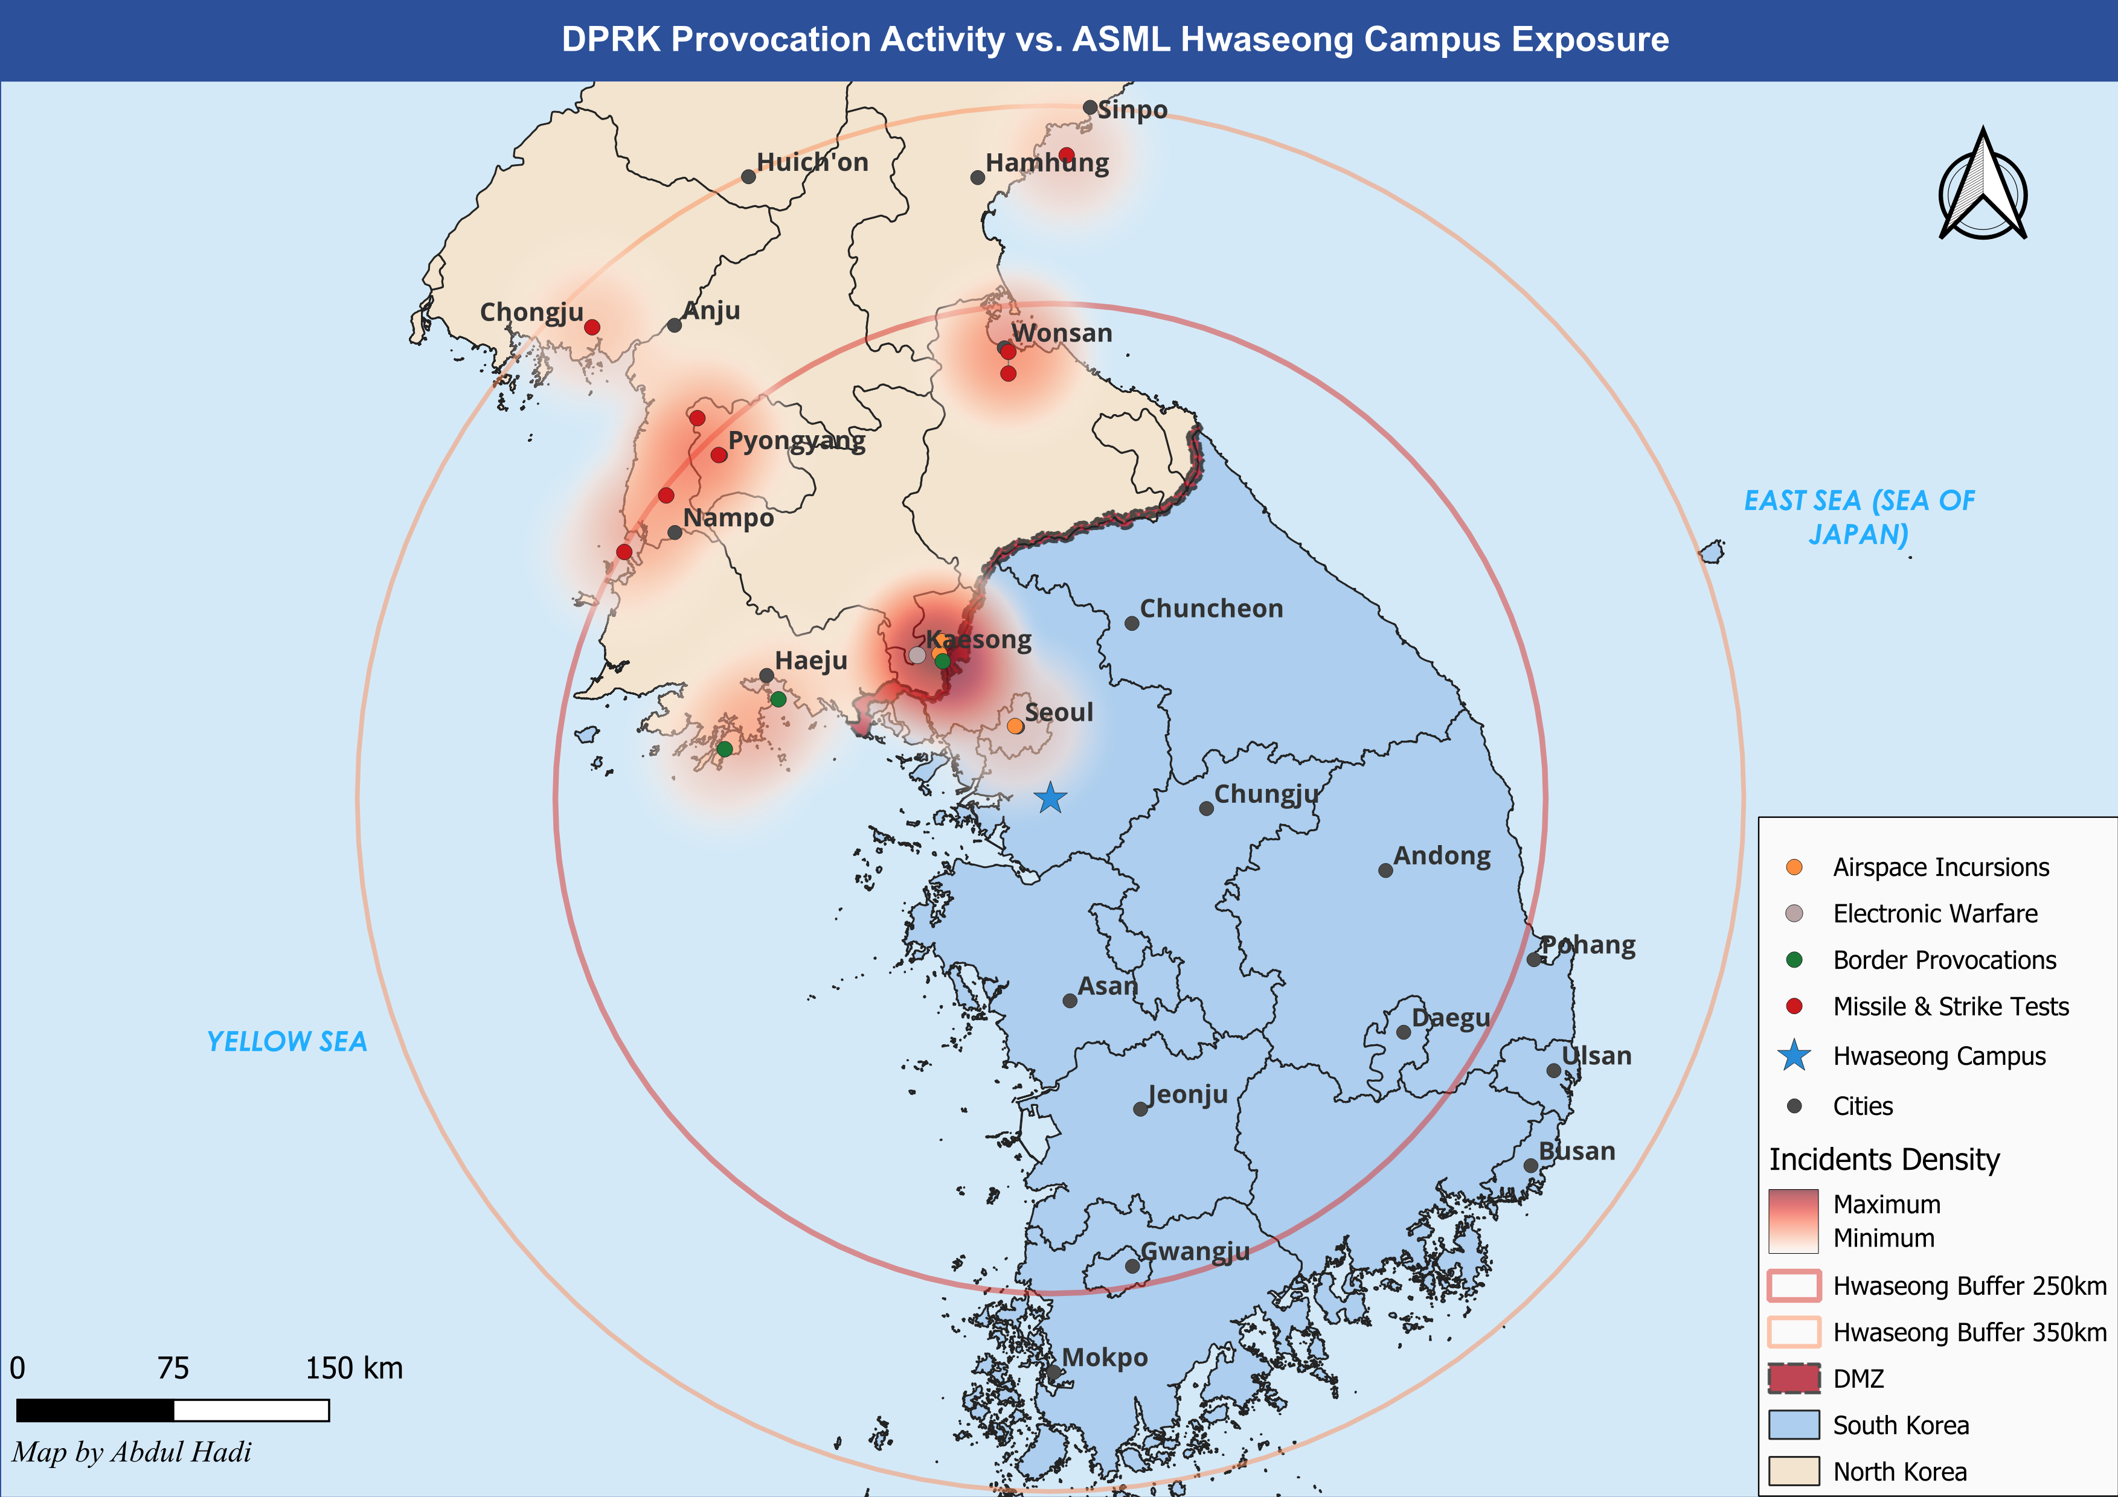
Forward Risk Scenarios
Scenario A: Status quo escalation
Activity continues at roughly 0.34 significant incidents a month, with the recent tilt toward missile and strike testing holding steady. No direct physical impact on Hwaseong expected, though it keeps a low hum of operational uncertainty running under ASML's broader Korea presence.
Scenario B: Sharp escalation
A test failure over a populated or shipping lane area, a provocation timed around major US-ROK exercises, or something that hits Samsung or SK Hynix supply corridors directly could shift the regional risk picture quickly. The likely result is South Korea wide precautions (flight restrictions, elevated alert status) that catch Hwaseong up in a national response rather than anything targeting the facility itself.
Scenario C: De-escalation
A diplomatic opening, or an internal shift in DPRK priorities, could bring testing down. Less likely given where the recent trend is pointing, but not off the table. North Korea's provocation cycles have had quiet periods before, usually tied to internal political timing.
These probabilities are a judgment call based on the trend and the base rate data, not a statistical model.
Crisis Response Protocol
Two trigger tiers, matching the two tier risk picture above.
Tier 1, facility level.
Any incident within the 250km near band involving a confirmed strike, incursion, or direct targeting of South Korean territory. Routine testing or launch activity, which the data shows is common and not aimed at anyone, doesn't count.
Tier 2, supply chain level.
Any incident, regardless of distance from Hwaseong, that disrupts Samsung or SK Hynix fabrication operations, logistics, or personnel movement in Korea.
Immediate actions:
- Confirm Hwaseong campus personnel safety and Repair and Reuse Center operational status.
- Contact Samsung and SK Hynix account leads directly to check on customer side impact.
- Suspend non-essential travel to and from the campus pending a 24-hour reassessment.
Escalation Chain
Site security lead, then Korea country manager, then ASML global crisis management team, then executive leadership. If Tier 2 is triggered, Samsung and SK Hynix account teams get notified in parallel with this chain, not after it.
External Communication
Have a hold statement ready in advance. Nothing public beyond confirming employee safety and Repair and Reuse Center service continuity until facts are confirmed through official ROK or US channels.

One-Page Quick-Reference Appendix
TIER 1, Facility level trigger (strike, incursion, or targeting within 250km)
- Confirm personnel safety, immediate
- Suspend non-essential site travel, immediate
- Notify site security lead, then Korea country manager, then global crisis team, within 1 hour
- No public statement until facts confirmed via official channels
- Reassess after 24 hours
TIER 2, Supply chain trigger (any distance, Samsung or SK Hynix disruption)
- Contact Samsung and SK Hynix account leads, immediate
- Assess Repair and Reuse Center service backlog risk, within 4 hours
- Notify global crisis team in parallel with customer outreach
- Prepare customer facing service continuity statement if disruption exceeds 48 hours
Escalation reference:
Site security, then Korea country manager, then global crisis team, then executive leadership, for Tier 1. Parallel Samsung and SK Hynix account notification for Tier 2.

